From Satellite to Silos: Predicting County-Level Corn Production in Minnesota Using Data Fusion

Tang Zi Jian (Jacob), Emma Wele, Victor C, Onishi Rei, Mansoor Naseef, PhD
November 29, 2025

Abstract— Agriculture is the cornerstone of the United States economy, with corn production contributing significantly to the livestock, food, and biofuel industries. In Minnesota, corn production generates over $8 billion in annual cash revenue and supports over 50,000 jobs. Accurate county-level corn production prediction is vital for informed decisions by farmers, policymakers, and traders. Yet traditional methods often fail to integrate complex environmental and economic factors. This research presents a machine learning (ML) benchmarking framework for corn prediction in Minnesota at the county level by integrating various sources of data, primarily environmental, agricultural, and economic. Data sources include the Global Land Data Assimilation System (GLDAS), Parameter-elevation Regressions on Independent Slopes Model (PRISM), USDA Economic Research Service (ERS), U.S. Energy Information Administration (EIA), and U.S. National Agricultural Statistics Service (NASS). The data from these sources were used to generate 64 essential features which were used to train and evaluate eight ML algorithms spanning linear baselines to gradient boosting and deep learning models. Of the various models evaluated, the LightGBM model achieved the best performance with an R² of 0.973 and a root mean squared error (RMSE) of 2,214,708 bushels (Bu). From our feature importance analysis, we revealed that economic proxies (fuel cost, income, federal receipts) and environmental variables (soil moisture, temperature) are critical when acres planted are unavailable.
Keywords — Corn Yield Prediction, Data Fusion, Machine Learning.

Introduction
In Minnesota, the agriculture sector is anchored by corn production, generating over $8 billion in annual revenue, contributing approximately 6% to the state’s GDP through direct and indirect effects (including $5.2 billion from the ethanol industry alone in 2024), and supporting nearly 47,500 jobs with $2.65 billion in wages as of 2023 [16]. This vital industry faces heightened vulnerability to Midwest-specific climate events, such as increasingly frequent and intense droughts (with some degree occurring nearly every year, including the severe 2021 event) and seasonal flooding from heavy rains, which disrupt planting, harvests, and overall yields amid broader climate change impacts like altered growing zones and extreme weather patterns [12].
Traditional prediction methods typically rely on historical production records; however, these often fail to factor in geospatial factors such as Normalized Difference Vegetation Index (NDVI), Land Surface Temperature (LST), climate, and economic factors which directly influence production. Direct measurements of soil macronutrients (e.g., N, P, K) and micronutrients (e.g., Fe, Zn) are challenging due to the large scale and need for manual ground sampling [7, 6].
In recent years, satellite remote sensing has revolutionized this domain by delivering decade-long temporal data which can be used to enhance machine learning (ML) model performance. NASA’s Global Land Data Assimilation System (GLDAS) integrates satellite and in-situ observations for multiple variables like soil moisture, temperature, evapotranspiration, and precipitation, while PRISM offers high-resolution climate data accounting for topographic influences. Factors like macro and micronutrients are effectively proxied through satellite-derived environmental variables such as spectral indices and soil moisture that reflect viability and crop health.
Prior research extensively utilized remote sensing for crop yield prediction, employing data from various earth observation satellites like MODIS, Landsat, and Sentinel-2 to derive vegetation indices (e.g., NDVI, EVI) and thermal signals (infrared spectral band) with models like Random Forest, Support Vector Machines, deep learning architectures like CNNs, LSTMs, and various gradient boosting algorithms (LightGBM and XGBoost) [7, 10, 11, 13, 14, 15, 5, 3, 8]. However, these works predominately focus on biophysical and environmental factors with very limited integration of economic data such as commodity prices, fuel costs, or government subsidies. In addition, most rely on single algorithms or similar comparisons rather than comprehensive benchmarks. While environmental conditions play a vital role in corn yield prediction, they are not the only factor that influences yield. Economic factors including fuel costs, commodity prices, government support programs, and market access significantly influence planting decisions, input intensity, and ultimately production levels [16]. Transportation infrastructure, particularly proximity to processing facilities such as ethanol plants, affects market access and profitability. This gap accentuates the novelty of our approach, which combines multi-source remote sensing with economic and infrastructure signals using advanced gradient boosting and deep learning models to capture more complex patterns. A comprehensive yield prediction framework must therefore integrate multiple heterogeneous data sources beyond satellite-derived environmental variables.
This research extends previous work by developing a comprehensive benchmark framework that systematically integrates five primary data sources: (1) GLDAS satellite- derived environmental variables, (2) USDA corn harvest data, (3) economic indicators from USDA Economic Re- search Service, (4) diesel fuel prices as proxies for operational costs, and (5) PRISM precipitation and temperature data. This study focuses on Minnesota counties (Federal Information Processing Standard codes 27001-27171) over 2000-2022, providing a rich temporal and spatial dataset encompassing 87 counties over 23 years.
The contribution of this research is as follows:
- We constructed a multi-source county-year multi-source data fusion dataset for Minnesota integrating GLDAS, PRISM, National Agricultural Statistics Service (NASS), Energy Information Administration (EIA), Economic Research Service (ERS), and ethanol plant distance data, demonstrating how heterogeneous data sources can be seamlessly integrated into various models for agricultural prediction and multi-source data fusion can overcome gaps in direct agricultural measurements (e.g. acres planted).
- We analyzed feature importance to identify which environmental and economic/infrastructure signals best compensate for the absence of acres planted, revealing that economic proxies and environmental variables provide strong predictive power when direct agricultural area measurements are unavailable.
- We evaluated eight ML models (Polynomial Regression, SVM, Random Forest, XGBoost, LightGBM, TabNet, LSTM, TCN) for predicting corn production. Based on our study, LightGBM depicts the best performance with an R² of 0.973.

Background and Related Works
Satellite remote sensing data combined with ML techniques for agricultural yield prediction has emerged as a rapidly evolving field, encompassing multiple sensor modalities: Synthetic Aperture Radar (SAR) systems which provide all weather capability, sensitivity to soil moisture, and vegetation structure [13, 5]; optical imagery from sensors such as Landsat, MODIS, and Sentinel-2 provides vegetation indices (NDVI, EVI, GNDVI) that capture photosynthetic activity and crop health [7]; hyperspectral and thermal sensors enable estimation of biochemical properties and water stress. Yield prediction is often improved when using multimodal approaches combining these data types, but faces challenges such as cloud contamination, scale mismatches between pixel resolution and field/county boundaries, and vegetation interference during growing seasons [15].
Machine learning has improved agricultural yield prediction by using data-driven modeling of complex, nonlinear relationships. Random Forest (RF) has been widely applied for its interpretability and robustness [11]. Gradient Boosting methods including XGBoost [3] and LightGBM [8] demonstrate superior performance for tabular regression tasks through sequential error correction. Deep Learning approaches such as CNNs [10, 14] and LSTMs often require large datasets and may not align well with tabular agricultural data where independent samples (counties, years) are more common than true temporal sequences.
Agricultural yield is impacted by environmental conditions, economic factors (e.g., commodity prices, fuel costs, and government support programs), technological advances, and policy influences [4, 6]. Recent research trends emphasize the integration of heterogeneous data sources beyond satellite-derived environmental variables to reflect this. Soil property databases, crop-specific datasets, and market logistics data provide additional context. Many of the prior studies rely on environmental/remote sensing data and focus on single algorithms or limited comparisons, rather than incorporating economic and infrastructure related variables at the county level. This work is novel in combining environmental, agricultural, and economic/infrastructure data at the county level in Minnesota, and in analyzing performance without acres planted, demonstrating compensatory mechanisms when primary features are unavailable.

Corn Production Dataset Construction
Given features x_{c,t} for county c in year t, we predict total corn production y_{c,t} (bushels). We constructed the dataset by integrating data from five primary data sources. The data is then consolidated at the county-year level using Federal Information Processing Standard (FIPS) codes for Minnesota counties (27001-27171). The consolidation process employs left joins to preserve all base observations while integrating supplementary data sources, with temporal alignment ensuring proper matching of monthly and yearly aggregations. The following subsections discuss the dataset construction process in detail.

Environmental Data from GLDAS
The GLDAS environmental variables were obtained from NASA Goddard Earth Sciences Data and Information Services Center (GES DISC) data portal [9]. GLDAS synthesizes data from multiple satellite sensors including MODIS, AMSRE, and ground-based weather stations, producing land surface variables at 0.25° spatial resolution globally [12]. The monthly GLDAS data was downloaded and aggregated to annual resolution for each county by computing means for continuous variables and appropriate aggregations for accumulated variables, providing environmental context for growing season conditions.
The dataset includes 36 GLDAS-derived features across multiple categories: atmospheric variables (air temperature, surface pressure, wind speed, specific humidity), radiation variables (longwave and shortwave downward radiation), evapotranspiration components (bare soil evaporation, canopy evaporation, total evaporation), soil variables at multiple depths (0-10cm, 10-40cm, 40-100cm, 100-200cm) including moisture and temperature, surface variables (albedo, average surface temperature, canopy interception, vegetation temperature), and hydrological variables (surface runoff, subsurface runoff, snow depth, snow water equivalent).

Corn Production Data from USDA NASS
Annual county-level corn production data were obtained from the USDA NASS Quick Stats database [17]. The data were accessed through the NASS Quick Stats web interface and filtered for “ACRES PLANTED” data items. FIPS codes were constructed by combining State ANSI code (27 for Minnesota) with County ANSI code, converted to numeric format and zero-padded to 3 digits. The dataset includes annual corn production in bushels (bu) per county, which serves as our target variable. While NASS also provides acres planted data, we do not use acres planted as an input feature in our experiments. The data is collected for year 2000-2023.

Diesel Price Data from U.S. EIA
The monthly diesel fuel prices were accessed through the EIA website [18]. This data reflects the monthly national average diesel prices in USD per gallon. These prices serve as a proxy for operational costs and agricultural economic conditions, directly affecting farming operations including tillage, planting, harvesting, and transportation. This monthly data were merged on year and month to provide temporal vari ation in fuel costs throughout the growing season.

Economic Indicators from USDA ERS
Our dataset includes three key economic indicators: total farm-related income receipts per county, farm-related income per agricultural operation, and federal government program receipts per county. These data were collected from the USDA ERS website. These indicators capture farmer income, government support levels, and economic conditions affecting production decisions. However, the data exhibits inconsistent temporal coverage with missing years for many counties (20-50% missing values), requiring multi-strategy imputation as discussed in section IV.

Climate Data from PRISM
Monthly precipitation and temperature data were obtained from the PRISM Climate Group at Oregon State University. PRISM provides 4km resolution gridded climate data that captures topographic influences on precipitation and temperature patterns through parameter-elevation regression modeling, providing higher spatial resolution than GLDAS for climate variables. The dataset includes monthly precipitation, mean temperature, minimum temperature, and maximum temperature. Like other datasets, county-level aggregation was performed by employing various matching strategies such as FIPS exact match, partial match, and reverse matching with string cleaning to handle county naming inconsistencies.

Ethanol Plant Distance Data
To generate the distance of the ethanol plants in the country, we computed the distance of the nearest ethanol processing facility from the county centroids. This continuous distance variable was also discretized in four categories: Very Close (0-25km), Close (25-50km), Medium (50-100km), and Far (>100km). These categories were then one-hot encoded using create binary features, while the original continuous distance was retained. This spatial feature reflects transportation costs and market access, where proximity to processing facilities influences profitability and production incentives. The feature is static (same for all years per county) as infrastructure locations do not change annually.
Finally, we integrated all this data using FIPS codes and standardized name matching. The dataset spans 2000-2022 (23 years) across 87 Minnesota counties, resulting in 12,026 samples with 64 engineered features (excluding acres planted). The target variable ranges from 5,900 to 56,800,000 bushels per county-year, exhibiting substantial heterogeneity requiring robust modeling approaches. A summary of the variables and data sources for the variables in the data set is shown in Table 1.

Model Design
In this section, we discuss the model design process for predicting county level corn production in Minnesota.

Data Preprocessing and Feature Engineering
After analyzing the dataset, we found that the corn production data is right-skewed. So before training the models we first apply a log transformation (i.e. log(1+x)) to normalize the distribution. To handle outliers, all numeric features were first scaled using robust scalar and then IQR-based outlier detection was applied to remove the outliers. For missing data, we adopted a multi-strategy imputation approach. For features with less than 20% missing values, we applied forward fill, backward fill, and median fallback. For features with 20-50% missing values, we used direct median imputation. Features with more than 50% missing values were dropped. Economic indicators with extensive gaps used a six-strategy method, including temporal interpolation and county/year-specific medians.
Feature engineering created 64 informative features across multiple categories. Temporal features include yearly trends and cyclical month encoding (sine/cosine transformations). Soil moisture features include averages across depths and gradients. Temperature features include averages, ranges, and PCA components (2 principal components from temperature features). Water balance features include precipitation-evapotranspiration balance and precipitation efficiency (soil moisture per unit of precipitation). Economic interaction features include total revenue sources and government receipts. Spatial features include ethanol plant distance categories. We excluded the acres planted as an input feature in our experimentation.
We constructed a temporal train-test split. The training set encompasses years 2000-2019 (10,409 samples), test set covers years 2020-2022 (1,617 samples). This prevents data leakage. All the preprocessing steps were only performed on the training data.

Models Selection and Evaluation

To establish a robust ML benchmarking framework, we selected eight ML models representing three distinct categories of model complexities: Linear baselines low complexity models, tree-based medium complexity models and deep learning high complexity architectures. The selection of specific model was driven by the diverse multi-source nature of our dataset, which combined temporal environmental, infrastructure data and economic indicators.

We employed polynomial regression and support vector machines as our baseline low complexity models. These models while effective for simple relationships we anticipated might struggle with our multi sourced dataset, which can include complex nonlinear interactions inherent in agriculture settings. Consequently, we implemented three tree-based methods: Random Forest, LightGBM and XGBoost. These models were chosen for their proven reliability on tabular data and multicollinearity among features. LightGBM, specifically, was configured with a decision-tree framework to efficiently capture feature relationships using leaf-wise growth while maintaining computational efficiency

Finally, to investigate the potential of sequential modeling due to the temporal nature of the dataset, we deployed deep learning architectures including TabNet, Long Short-Term Memory (LSTM) Networks and Temporal Convolutional Networks (TCN). Given that crop growth is a biological process as well as temporal dependencies in monthly GLDAS and EIA data, TCN and LSTM were selected. TabNet was included to evaluate if attention-based mechanisms could better capture or select features from the high dimensional input space (64 features)

To rigorously evaluate model performance and prevent data leakage, we employed a temporal train-test split rather than random K-fold cross validation. The training set comprised of historical data from years 2000-2019 (10,409 samples). While the test set comprised data from years 2020-2022 (1,617 samples). This split simulated real world forecast where the future is not known, and prediction is based solely on historical knowledge.

All preprocessing steps, including log-transformations and standardization, were fitted on the training data and applied to the test set. Model performance was assessed using four metrics: Coefficient of Determination R² to measure the proportion of variance explained; Root Mean Squared Error (RMSE) and Mean Absolute Error (MAE) to quantify the magnitude of prediction errors in bushels; and Mean Absolute Percentage Error (MAPE) to provide a relative error measure interpretable vastly different production volume. Hyperparameters were optimized using a hybrid approach of grid search and random search, utilizing early stopping to prevent overfitting during the training.

Experimental Results
In this section, we discuss the result from our experimentation followed by an analysis of the features that we found most important for predicting corn production.

Comparative Performance Study

We compared the performance of eight models (Table 2) in this work. These models include Polynomial Regression SVM (SVR), Random Forest, XGBoost, LightGBM, TabNet, TCN (Dense Surrogate), and LSTM. The performance of the models is evaluated based on R², root mean square error (RMSE), mean absolute error (MAE), and mean absolute percentage errors (MAPE). Table 3 lists the performance of the models used in this comparative study.
Tree-based gradient boosting models are highly effective at modelling heterogeneous tabular data with complex, nonlinear interactions. LightGBM is well-suited for structured datasets, leveraging its decision-tree framework to efficiently capture feature relationships and patterns. This is also reflected in our experimentation. As can be observed from Table 3, the LightGBM model is able to capture the non-linear relationship with the lowest R² score of 0.973. Fig. 1 plots the predicted corn production against actual corn production for the LightGBM model. Other tree-based ensemble models (XGBoost, Random Forest) also depict higher R² value with lower RMSE and MAE numbers compared to other models in this comparative study. We also observe that complex deep learning models is unable to perform well compared to the tree-based ensemble methods.

Deep learning models, while powerful, underperformed in this specific context, with the LSTM and TCN achieving R² scores of 0.874 and 0.863 respectively. This performance gap can be attributed to the sample size; with approximately 12,000 samples, the dataset may be sufficient for ensemble trees but falls short of the massive scale typically required to optimize the millions of parameters in deep neural networks.
A critical finding of this study is the model's high predictive accuracy (R² > 0.97) without the inclusion of "acres planted" data. Traditionally, acres planted is the strongest predictor of production. However, our feature importance analysis (Table 4) reveals that the model successfully compensated for missing acreage data by leveraging economic proxies. "Revenue per Bushel" and "Fuel Cost Proxy" ranked as the top two most important features, with "Farm-related Income" also appearing in the top five.
This indicates that economic signals, which drive planting decisions and input intensity, served as highly effective variables for agricultural predictions. For instance, high revenue per bushel incentivizes maximum planting, while fuel costs constrain operational scope by county. By fusing these economic indicators with environmental constraints (soil moisture and pressure), the LightGBM model was able to infer production levels with high precision, validating the hypothesis that multi-source data fusion can overcome gaps in direct agricultural measurements.

Feature Importance Analysis
To understand the features that plays significant role in predicting the corn production, we analysed the features in our dataset and ranked them based on their importance. Table 4 lists the top 15 features along with their absolute importance for the LightGBM model. From this set of features, we observed that economic and infrastructure proxies (revenue per bushel, fuel cost, income measures, ethanol plant distance) dominate the ranking, while multiple deep-soil and surface moisture metrics plus surface pressure, snowmelt runoff (Qsb acc), and soil-moisture gradient demonstrate the continued relevance of physical signals. Furthermore, we can observe that fuel cost indicators remain the single strongest signals when acres planted are excluded, acting as economic proxies for operational scale, whereas diesel pricing and federal receipts capture input costs and subsidy flows. At the same time, deep- and mid-layer soil moisture, total snowmelt runoff, and surface pressure ensure that LightGBM retains sensitivity to growing-condition dynamics rather than relying purely on economic data.

Limitations
The study has some limitations; it focuses specifically on counties in Minnesota over the years 2000-2022. The generalizability of this study to other states, crops, and temporal periods requires further investigation. Data gaps in economic indicators, though handled through multi-strategy imputation, could introduce uncertainties. Although the dataset is of moderate size, its performance suggests that the amount of data is sufficient for optimal modeling approaches, which may limit the advantages of deep learning.

Conclusion
This research presented a comprehensive benchmarking framework for predicting county-level corn production in Minnesota, addressing key limitations in traditional methods which fail to integrate complex economic and infrastructure factors. By constructing a novel multi-sourced dataset using NAS GLDAS, PRISM, USDA economic indicators and infrastructure metrics, we demonstrated that accurate production is achievable even without indicators like acers planted or direct measurements.

Our analysis of eight ML models revealed that gradient boosting algorithms offer superior performance for this application, achieving a R² score of 0.973 which significantly outperforms traditional ML models in previous studies as well as significantly outperforming deep learning and linear baselines. The success of LightGBM underscores the suitability of tree-based ensembles for analysing tabular data where biological, climatic, and economic features interact.

Furthermore, our feature importance analysis provided critical insights into the drivers of corn production. We identified that economic factors, specifically revenue per bushel, fuel costs, and farm income, plays a dominant role in predicting output. This validates our multi-source fusion approach, showing that agricultural output is a function of economic incentives, market access (ethanol plant proximity), soil moisture and temperature.
Future work will aim to expand this ML framework beyond Minnesota to test generalizability across different crops like beans on the wider Corn Belt states like Iowa. Additionally, there is also opportunity to integrate GLDAS data in real time to provide real time alerts or predictions for indicators like abnormalities in seasons or floods, providing farmers and policy makers the opportunity to mitigate risks in advance.

Acknowledgement
We used AI-assisted tools, composer1 for language editing and minor code generation for simple analysis. All research design, experiments, and analysis were performed by the authors.

References
- Arik, S. O., & Pfister, T. (2021). TabNet: Atten- tive interpretable tabular learning. Proceedings of the AAAI Conference on Artificial Intelligence, 35(8), 6679–6687.
- Bai, S., Kolter, J. Z., & Koltun, V. (2018). An em- pirical evaluation of generic convolutional and recur- rent networks for sequence modeling. arXiv preprint arXiv:1803.01271.
- Chen, T., & Guestrin, C. (2016). XGBoost: A scal- able tree boosting system. Proceedings of the 22nd ACM SIGKDD International Conference on Knowl- edge Discovery and Data Mining, pp. 785–794.
- Desloires, J., Mestre, P., Baret, F., & Weiss, M. (2024). Early season forecasting of corn yield at field level from multi-source satellite time series data. Re- mote Sensing, 16(9), Article 1573.
- European Space Agency. (2025). Copernicus: Sentinel-1.
- Ji, Z., Pan, Y., Zhu, X., Wang, J., & Li, Q. (2022). Prediction of corn yield in the USA corn belt using satellite data and machine learning: From an evapo- transpiration perspective. Agriculture, 12(8), Article 1263.
- Kayad, A., Sozzi, M., Gatto, S., Whelan, B., Pirotti, F., & Marinello, F. (2019). Monitoring within-field variability of corn yield using sentinel-2 and machine learning techniques. Remote Sensing, 11(23), Article 2873.
- Ke, G., et al. (2017). LightGBM: A highly efficient gradient boosting decision tree. Advances in Neural Information Processing Systems, 30, 3146–3154.
- NASA. (n.d.). GLDAS Noah Land Surface Model L4 monthly 1.0 x 1.0 degree V2.0. NASA Open Data Portal.
- Nevavuori, P., Narra, N., & Lipping, T. (2020). Crop yield prediction using multitemporal UAV data and spatiotemporal deep learning models. Remote Sens- ing, 12(23), Article 4000.
- Prasetyo, T. A., Sihombing, P., & Sitompul, O. S. (2024). Parameter optimization of the random forest algorithm for predicting corn yields in Toba Re- gency. Proceedings of the 7th International Seminar on Research of Information Technology and Intelli- gent Systems: Advanced Intelligent Systems in Con- temporary Society, pp. 1025–1029. ISRITI 2024.
- Rodell, M., et al. (2004). The Global Land Data Assimilation System. Bulletin of the American Meteo- rological Society, 85(3), 381–394.
- Roy, P. D., Sarkar, S., Pal, S. K., & Chakrabarti, A. (2025). Retrieval of surface soil moisture at field scale using Sentinel-1 SAR data. Sensors, 25(10), Article 3065.
- Shahhosseini, M., Hu, G., & Archontoulis, S. V. (2021). Corn yield prediction with ensemble CNN- DNN. Frontiers in Plant Science, 12, Article 709008.
- Singh, R., Sharma, P., & Kumar, A. (2025). Cloud detection methods for optical satellite imagery: A comprehensive review. Geomatics, 5(3), 27–45.
- U.S. Department of Agriculture, Economic Research Service. (2000-2023). County-level economic indicators.
- U.S. Department of Agriculture, National Agricultural Statistics Service. (2000-2023). Quick Stats.
- U.S. Energy Information Administration. (2000-2023). Petroleum & Other Liquids.

A Pipeline Overview

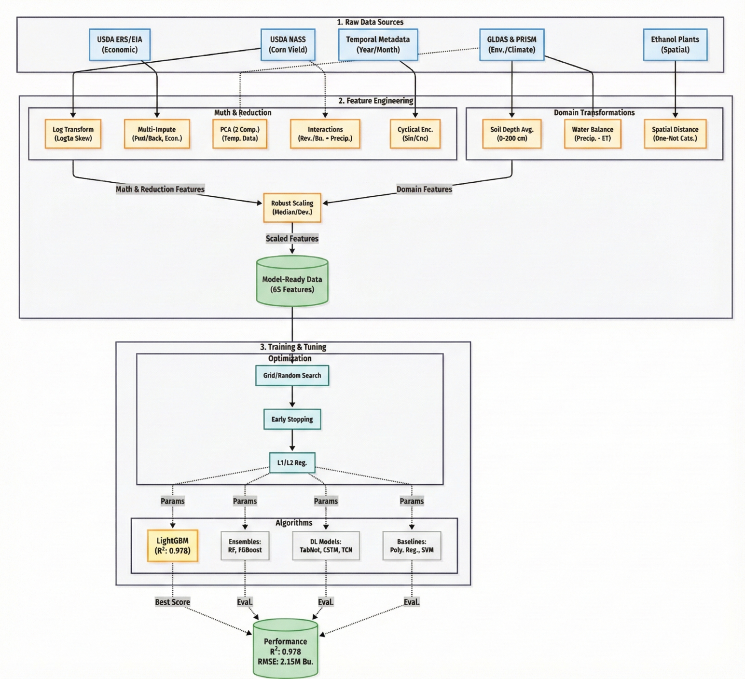
Figure 3: Pipeline Overview Diagram

